**Willify Documentation**

Name: Nico Valerian Marcello  
NIM: 2702250242  
Class: BA02 (Even Semester 2023/2024)

This document is a documentation that explains each Willify page that I’ve implemented during production of the website. Before explanation of each page, I’d like to describe the general layout of the pages.

Every page categorized into 3 parts: header, main, and footer:

* **Header**

The header is a sticky navigation bar that is split into 3 sections: logo wrapper, page directory, and authentication buttons.



This is the mobile look for the header, there’s a dropdown menu on the right side.

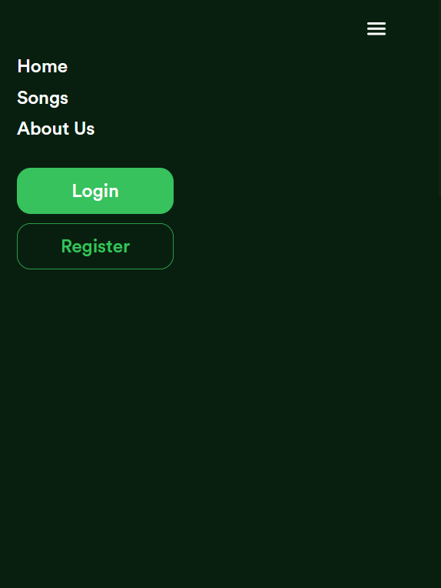

When users click the dropdown menu, user will be able to select the page that want to navigate to. They can return back to their page by clicking the dropdown menu icon again.

* **Main**

The main section is the central part of each page and is responsible for displaying the primary content. It is later divided into various subsections depending on the specific page functionality.

* **Footer**



The footer includes contact information, links to important site pages (like privacy policy, terms of service).



Here is the mobile/tablet version for the footer, not much of a change except for font sizes and padding for each wrapper.

This structured layout ensures that users have a consistent and intuitive experience across the Willify website.

Here are the five pages I’ve implemented to the site:

1. **Home Page**

Desktop Look

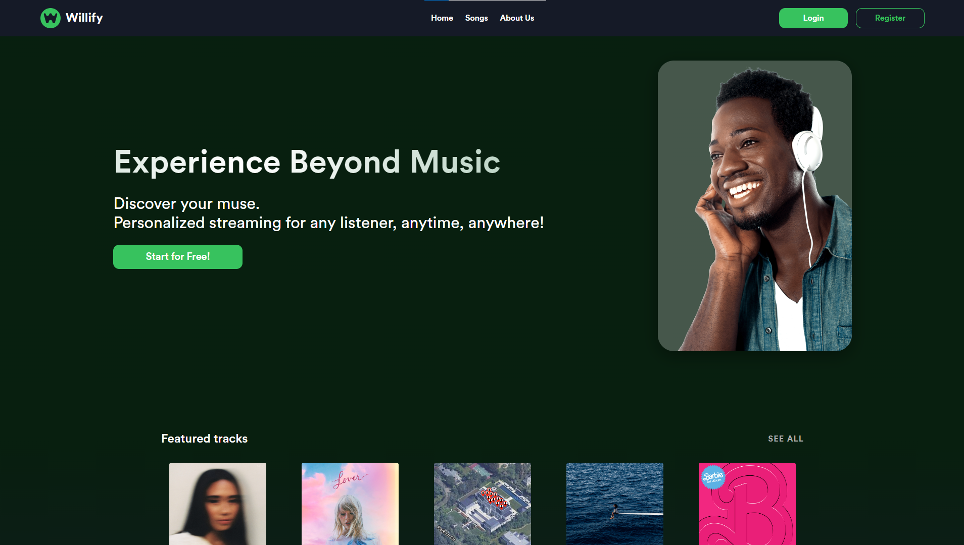

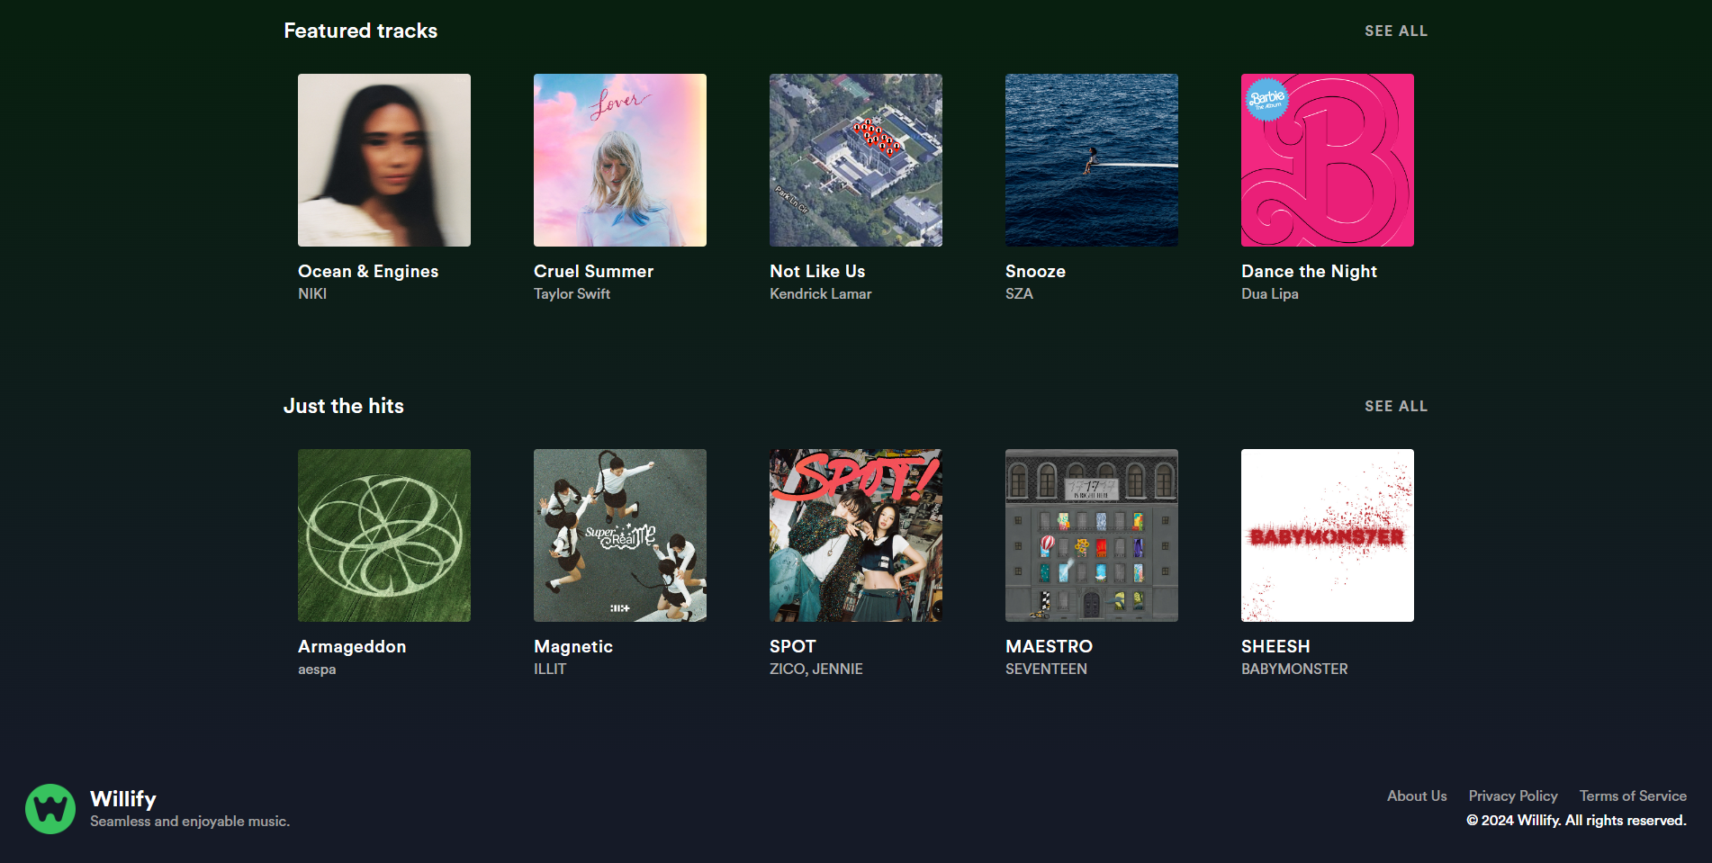

Tablet/Mobile Look

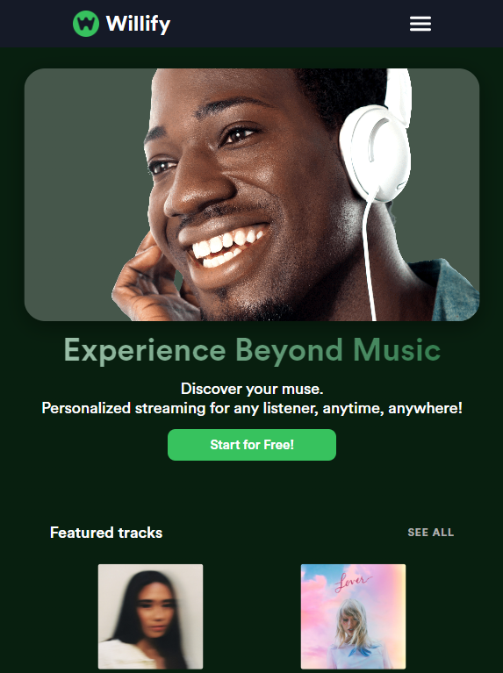 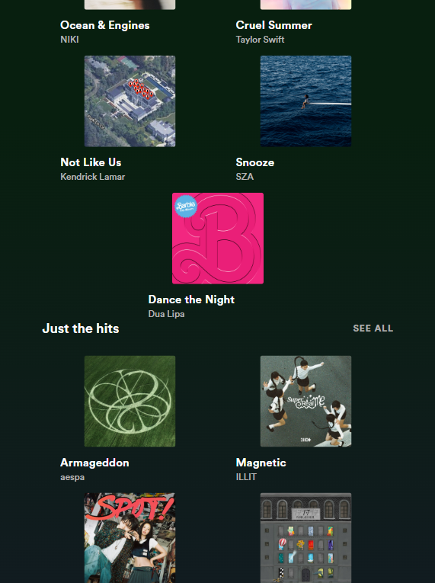 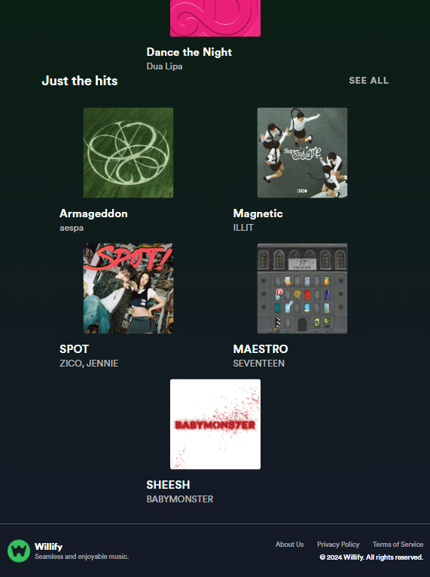

The Willify home page showcases a hero banner with a call-to-action button (“Start for Free!”), followed by sections for featured tracks and popular hits, each accompanied by album covers and artist information. There are also “see all” buttons that redirect the user to the songs page.

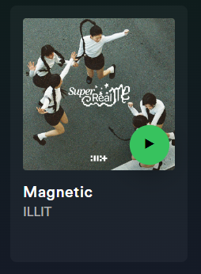

These song cards, if clicked, will redirect the user into the corresponding song details page.

1. **Songs Page**

Desktop Look

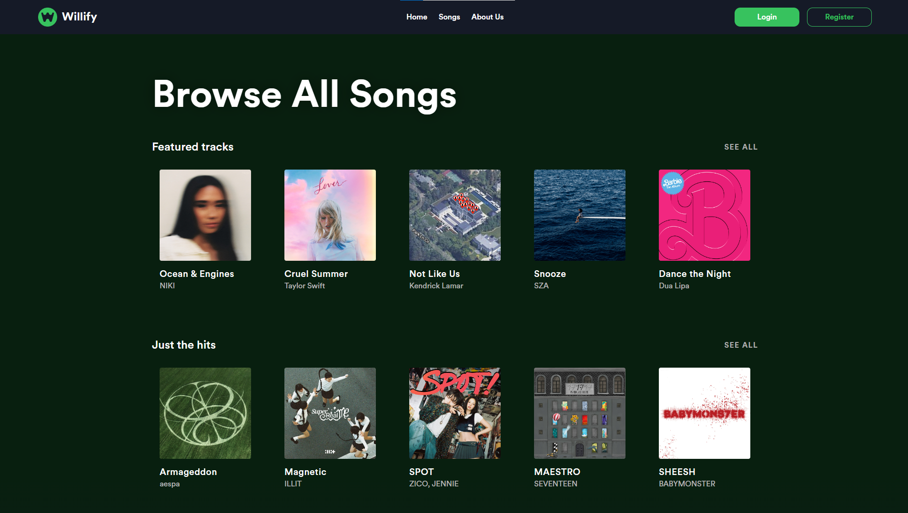

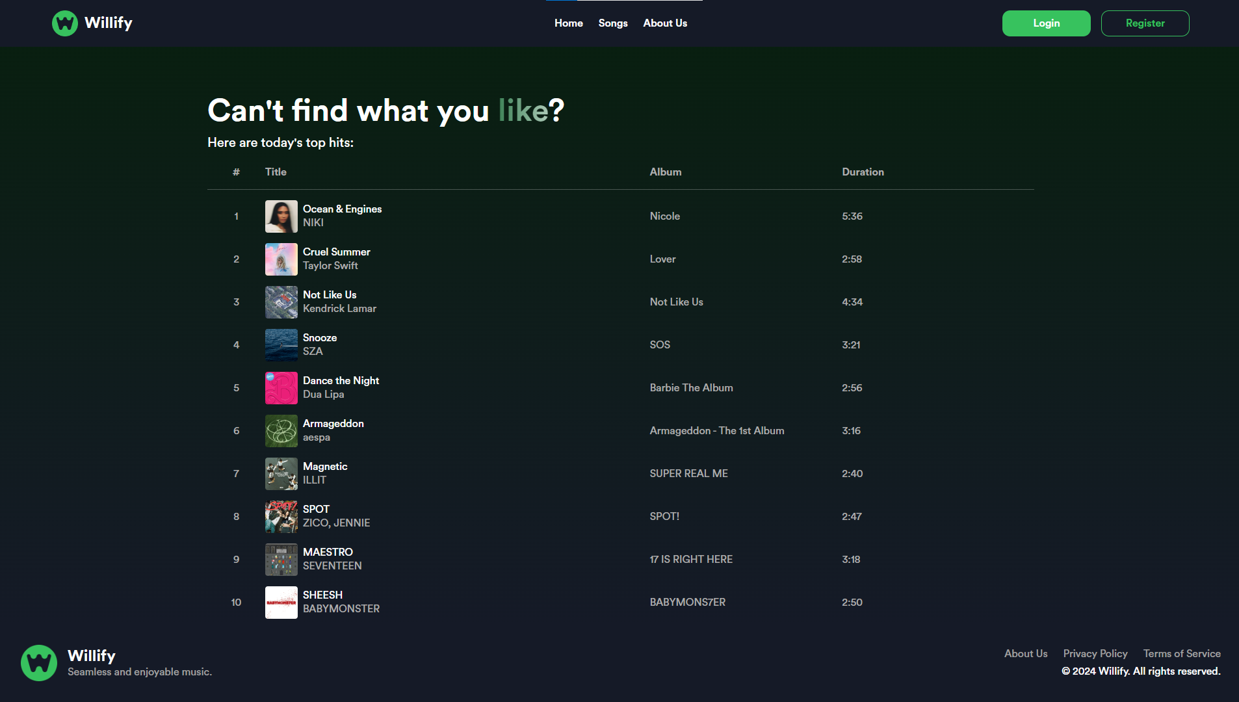

Mobile/Tablet Look

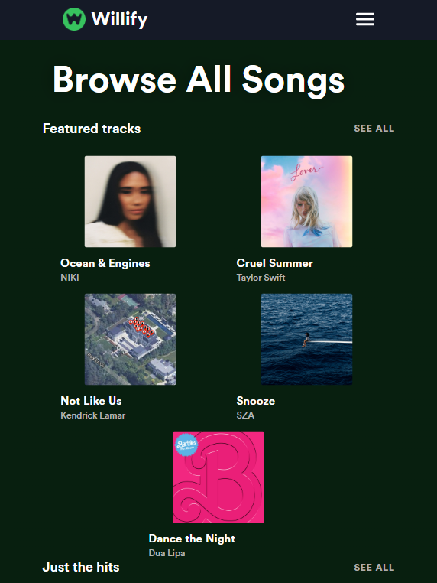 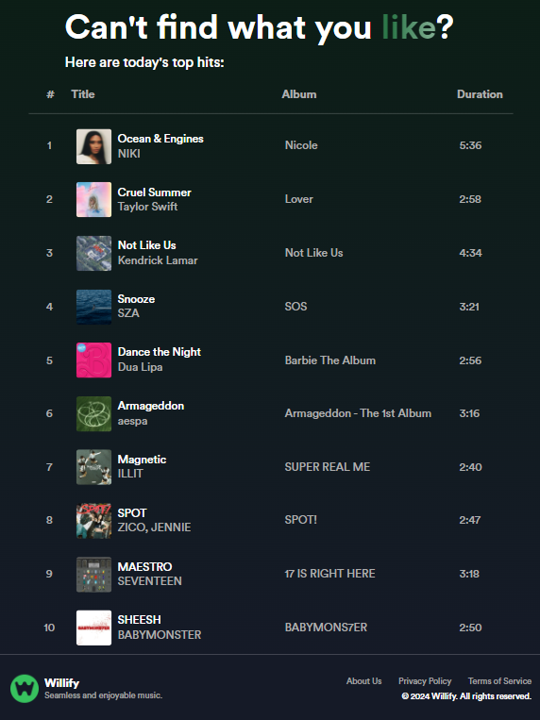

The songs page showcases two chart sections that contains five song cards each. They are similar to the one back in the home page (if clicked, will redirect the user into the corresponding song details page). Below that, is a table section, created with div (not the table tag). The user will be able to click each row of song to navigate to the corresponding song details page. The table’s layout is based on CSS Flexbox, so we can easily rearrange for mobile/tablet media queries. 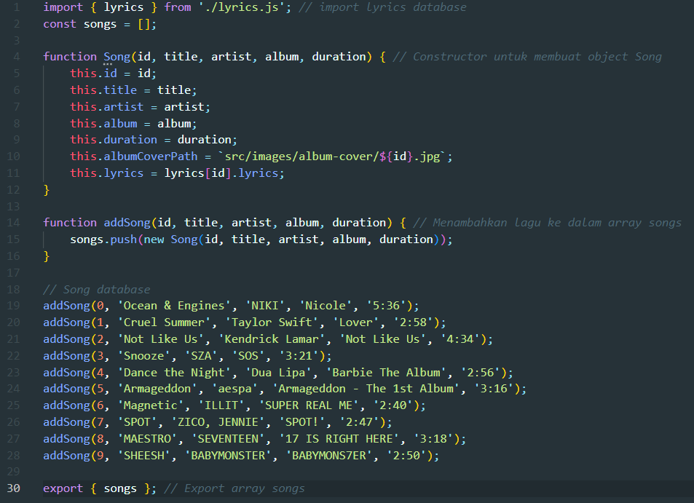

This code is found in *database.js*. Each song in the table is an object Song, each with 7 properties:

* id: unique song id
* title: song’s title
* artist: song’s artist name
* album: song’s album name
* duration: song’s duration
* albumCoverPath: song’s album cover image directory
* lyrics: song’s lyrics (which is imported from lyrics.js, more on this later)

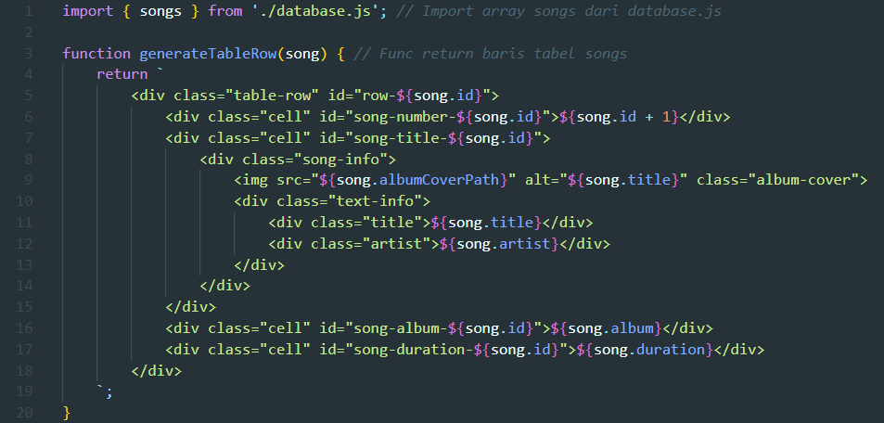

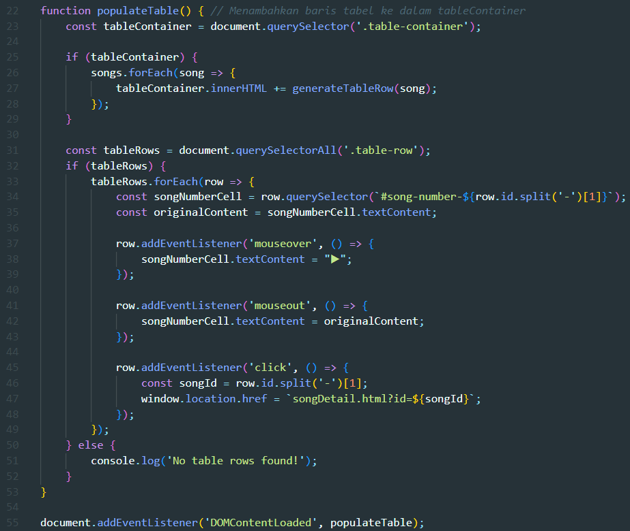

This code is found in *songs.js*. Each row in the table in the songs page is dynamically generated from the songs database.

1. **Song Details Page**

Desktop Look

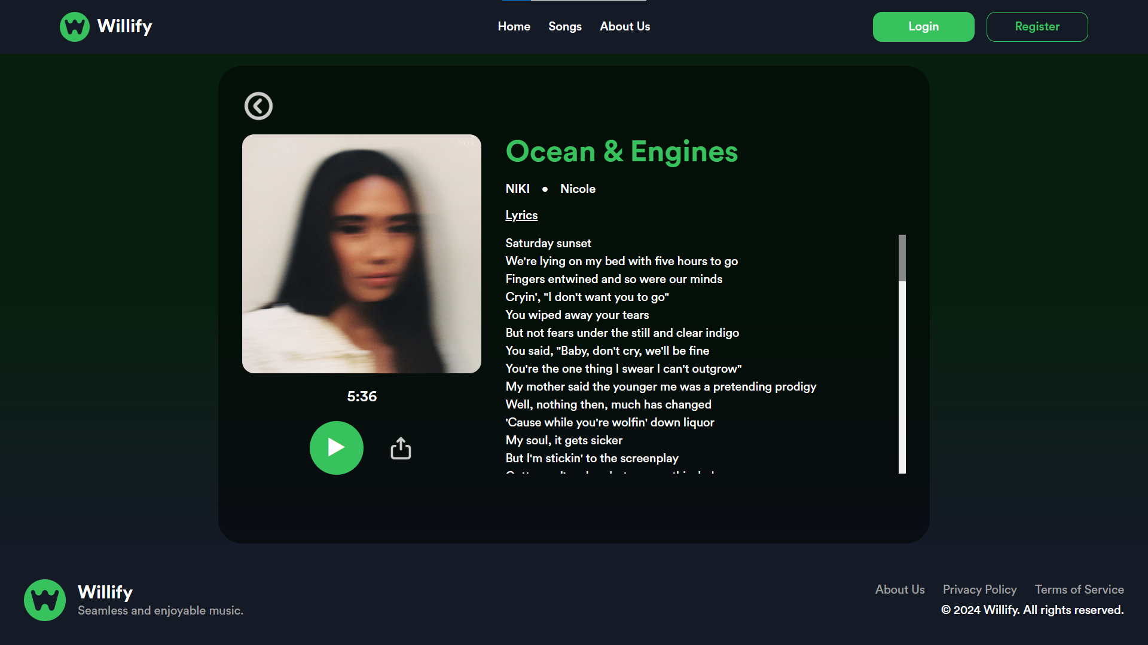

Mobile/Tablet Look

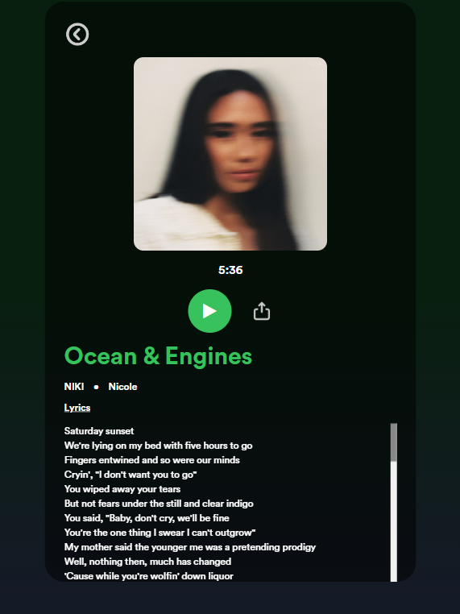

The song details page showcases each song’s general information, such as the song’s title, artist, album name, and lyrics. The page also has a back button on top, a play button, and a share button. There is only single page of html for all the songs available (there are 10).

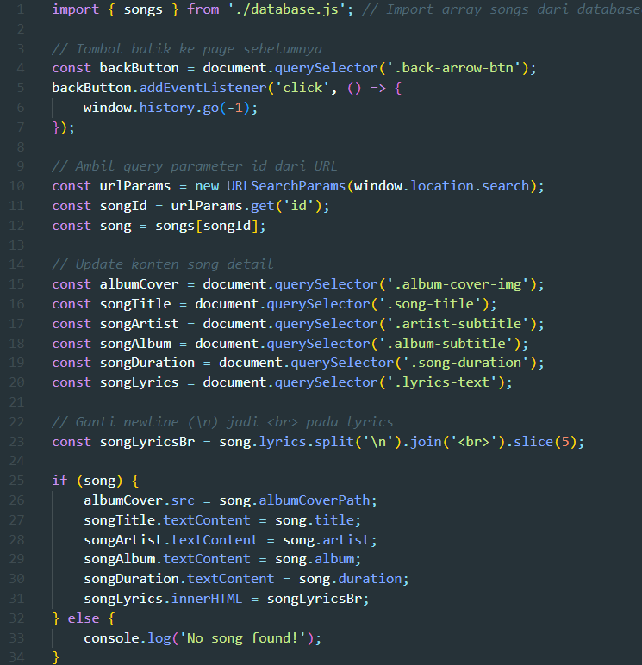

The script grabs the ‘id’ query parameter from the browser. Every song’s data is fetched from database.js and lyrics.js, then displayed according to the ‘id’ we grabbed using this piece of code (songDetail.js).

1. **Register (Sign Up) Page**

Desktop Look

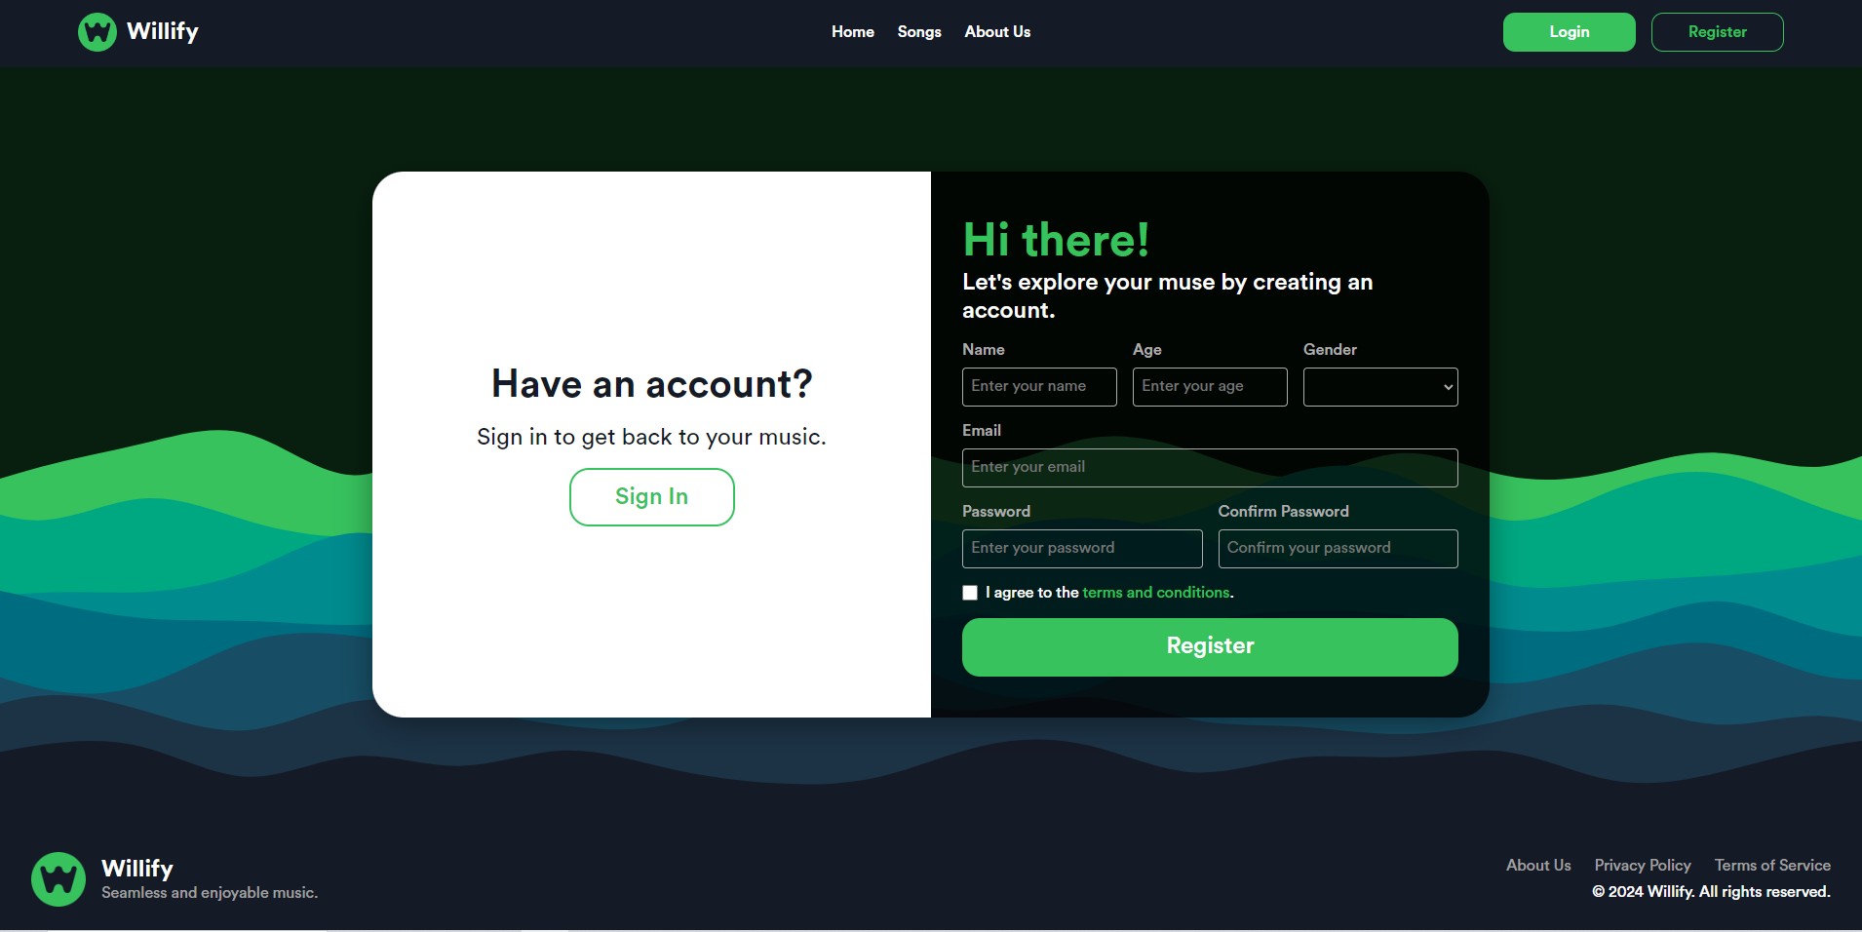

Mobile/Tablet Look

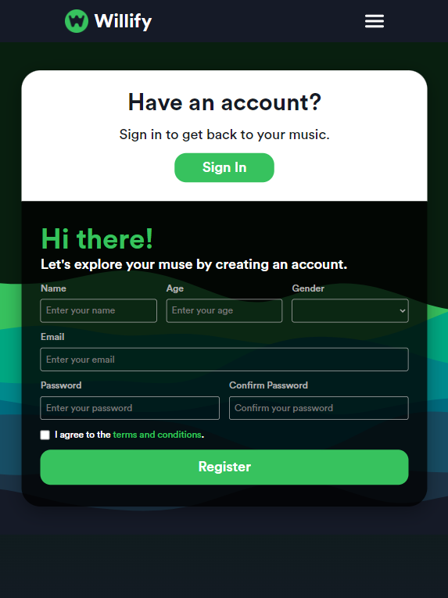

The registration page or sign up page contains a register form that users can fill in. The form contains 6 input forms: name, age, gender, email, password and password confirmation. Then, they are required to agree to the terms and conditions by clicking on the checkbox at the end of the form. They can click the green register button to register themselves. The website will validate those 6 inputs.

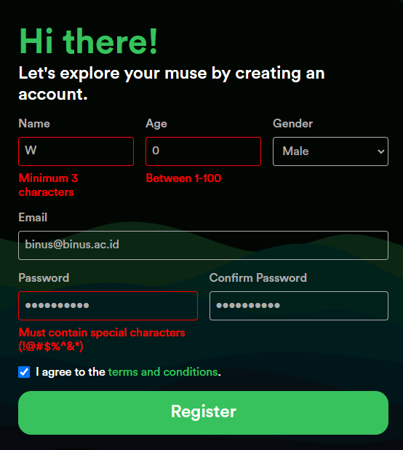

Here, we can see the user failing 3 of the inputs.

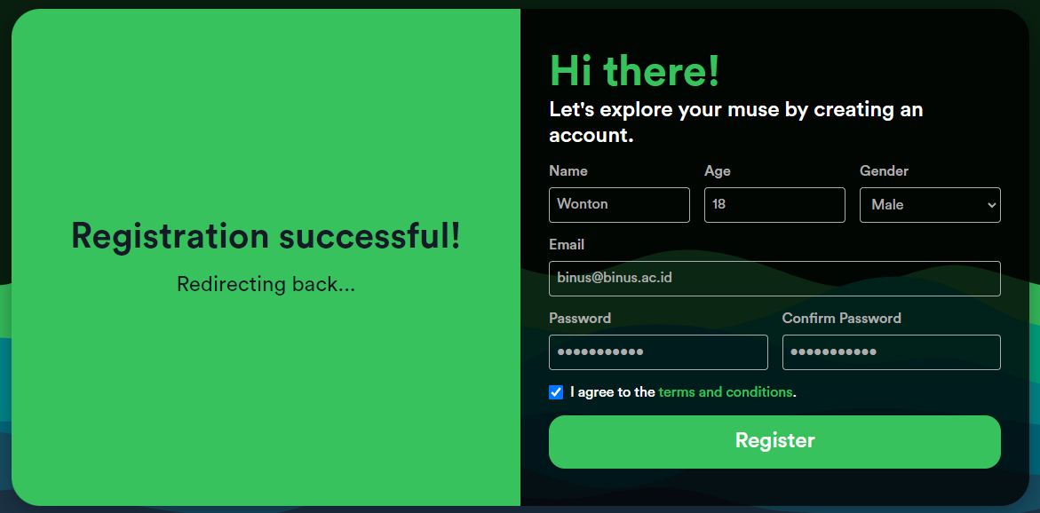

If the user is successful, they will be redirected back to the page before.

1. **About Us Page**

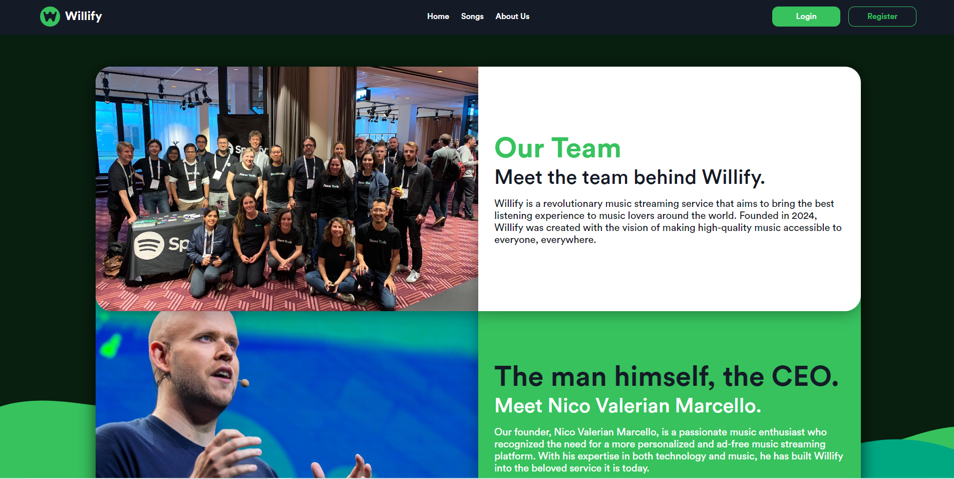

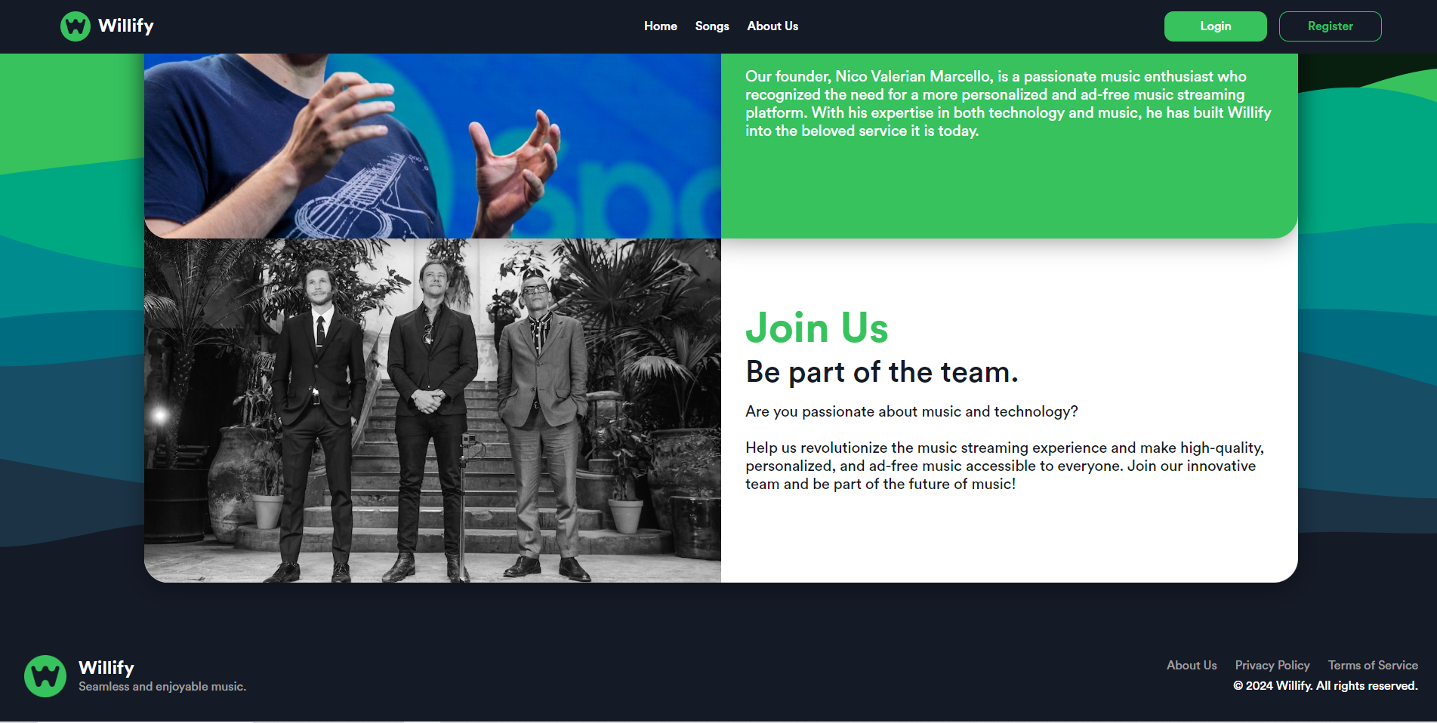

The about us page showcases three sections: the history and team of Willify section, the founder section, and a recruitment section. Each section provides the user information regarding Willify as a company and is an opportunity to tell Willify’s history, values, and vision. Each section is stacked on top of another to create a 3D effect.

**References**

* The cool animated gradient text is inspired by this article by web.dev

<https://web.dev/articles/speedy-css-tip-animated-gradient-text>

* The CSS input pseudo classes applied when user fills in the input form is made easy when I learn it from mdn web docs.

<https://developer.mozilla.org/en-US/docs/Web/CSS/Pseudo-classes>

* A lot of the layouts such as for the register page are inspired from UI/UX artists from Dribbble.

<https://dribbble.com/>

* The layered waves background is made in Haikei.

<https://haikei.app/>

* The password validation method that doesn’t use RegEx is inspired from GeeksForGeeks.

<https://www.geeksforgeeks.org/>